Manage Banks Use Case

Submitted to

Alpha Payments Cloud


Tarang Software Technologies Private Limited
Tarang Towers,
#400/2, Whitefield 100 ft road,
Hoody circle,
Bangalore, India
Phone: +91-80-41157777
WEB: www.tarangtech.com

© This document is exclusive property of Tarang software Technologies Private Limited. No part of this may reproduced in any form without written permission.

Document Change History

Ver# | Editor | Date | Reviewer | Approver | Changes made
0.1 | Sadanandh | 5th Sept 2012 | Bindu |  | Draft version
1.0 | Sadanandh | 7th Sept 2012 | Bindu |  | Base Version
1.01 | Sadanandh | 12th Sept 2012 | Ronan |  | Updated Version with review comments
Table of Contents
1 Introduction 4
2 Use Case: SEARCH BANKS 4
2.1 User Interface Information 5
2.1.1 User Interface details for search banks 5
3 Use Case: Add Bank 5
3.1 User Interface Information 6
3.1.1 User Interface details for Add Bank 7
4 Use Case: Edit Bank 8
4.1 User Interface Information 9
4.1.1 User Interface details for Edit Bank 9
5 Use Case: View Corporate List 10
5.1 User Interface Information 10
5.1.1 User Interface details for View Corporate List 10

Introduction

This document describes all the use cases for Bank Management. It includes Search Banks, Add/Edit Banks, in the APC system. To add/edit bank details to the APC system. This is the level 1 in the hierarchy of Banks, Corporate and Merchants.

Use Case: SEARCH BANKS

Title | Search Banks
Requirement ID | RID-1011
Actors | System Admin, APC User with appropriate privilege to search Bank based on role permission
Description | Actor should be able to search for the Banks in the APC system
Use case trigger | - When Actor selects the “Manage Banks” option from the main menu to search for the Banks
Main flow / Flow of Events | - On choosing the “Manage Banks“ option from the main menu, system shall display the list of recently created 20 banks with the list in descending order of creation date, shall include the search criteria’s:  Bank Name, Country and Status  Action - Search  - Actor shall enter the search criteria field values & click on “Search” button.  - System shall build the query based on the criteria entered & retrieve the matching records from the DB & display it in the table listing in the below mentioned format:  [Bank Name, Bank Code, Contact No, Status, Country and Corporate List]
Sub-flow/Alternate Flows/ Scenarios | - If the actor does not choose to enter any data in the search criteria’s then the system shall retrieve all the bank records.  - If there are no matching records for the search criteria chosen; system should display an appropriate message saying “No Records found.”  - Depending on the status criteria chose, Active/Inactive only the banks in the respective status should be retrieved.  - If the actor selects the row and clicks on edit link at the bottom of the table, system should navigate the actor to the corresponding bank edit screen. This feature will detailed out as part of separate use case.  - If the actor clicks on the “Add Bank” link at the bottom of the table, system should navigate the actor to the Add Bank screen. This feature will detailed out as part of separate use case.  - If the actor clicks on the “View” button in the corporate list column, system should navigate the actor to the Manage corporate screen with the corporate list for the corresponding bank. This feature will be detailed as part of separate use case.
Assumptions | -
Pre-conditions | Actor should be logged into the system & has the appropriate privilege to search banks.
Post-conditions | - Actor is able to retrieve the relevant Bank records from the system based on the search criteria chosen.
Status | Open
Issues
Business Rules | Search – Query should be for partial search. I.e. like “%string%”. So the minimal search keys that you enter should retrieve the maximum information. For ex: Search By name – “Car” should retrieve all the banks with the alphabet “car” in their names.

User Interface Information

User Interface details for search banks

Refer Manage Banks screen of the storyboard (manageb.html)

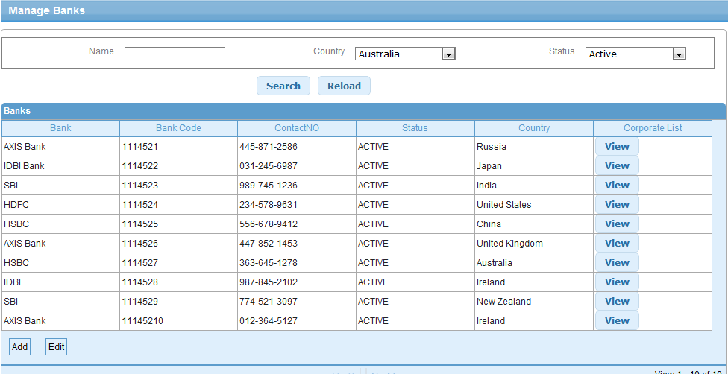

Validations for Search Banks
Will be updated later

Id | Parameter Name | Field Type | Special characters | Validations | Field Length | Possible Values | Additional Condition | Mandatory
1 | Name | Text Box
2 | Country | Drop downx
3 | Status | Dropdown |  |  |  | Active/Inactive

Use Case: Add Bank

Title | Add Bank
Requirement ID | RID-1012
Actors | System Admin, APC User with appropriate privilege to Add banks
Description | Allows the actor to add a Bank.
Use case trigger | - Actor chooses to click on “Add Bank” link/button from the Bank listing screen (Manage Banks)
Main flow / Flow of Events | - System shall navigate the actor to the Add Bank screen along with the following fields to be captured.  - details of the fields shown are:  - Bank Name  - Bank Code  - Contact Person  - Contact No  - Email Address  - Address1  - Address2  - City  - Country  - State/Province  - Zip/Postal Code  - Currency  - Time Zone  - Language  - Actor shall enter the relevant information & Click on Save.
Su  b-flow/Alternate Flows/ Scenarios | 3a. If the actor enters the invalid data, the Actor shall be navigated to the same screen with appropriate error message.
Assumptions | None
Pre-conditions | The actor is logged in to the application. and has the privilege to add new bank to the system
Post-conditions | - Add - New Bank will successfully be created in the system and the Actor will be navigated to the Bank listing screen with the newly created bank details.
Status | Open
Issues
Business Rules | Bank Name and Bank Code should be unique in the system,  State drop down list shall be based on the country selected for US, Canada , Australia  Contact number format shall be based on the country selected. Default contact number format shall be area code and number.

User Interface Information

User Interface details for Add Bank

Refer “Add Bank” screen of the storyboard
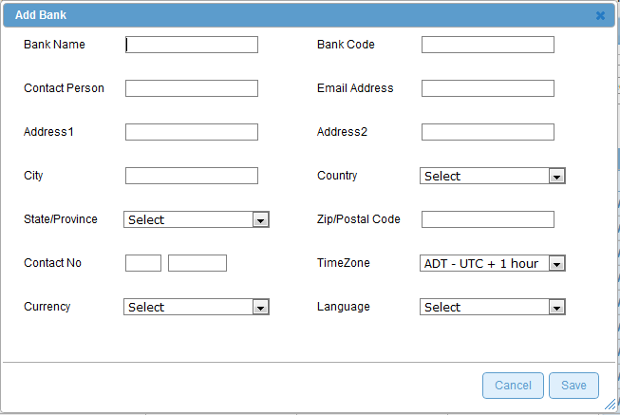

Validations for Add Bank

Id | Parameter Name | Field Type | Special characters | Validations | Field Length | Possible Values | Additional Condition | Mandatory
1 | Bank Name | Textbox
2  3  4  5  6  7  8  9  10  11  12  13  14 | Bank Code  Contact Person  Email Address  Address1  Address2  City  Country  State/Province  Zip/Postal Code  Contact No  Currency  Time Zone  Language | Textbox  Textbox  Textbox  Textbox  Textbox  Textbox  Drop down  Drop down  Drop down  Text box  Textbox  Drop down  Drop down |  | Valid email format eg abc@y.com  Specific to country  Specific to country, |  | will be area code and number by default

Use Case: Edit Bank

Title | Edit Bank
Requirement ID | RID-1013
Actors | System Admin, APC User with appropriate privilege to Edit Bank
Description | Allows the Actor to Edit Bank details
Use case trigger | - Actor selects the row from the bank listing grid and clicks on the Edit link at the bottom of the table or double click on the selected row
Main flow / Flow of Events | System shall navigate the actor to the Edit Bank screen along with the following fields to be updated.  details of the fields with the existing values shown are:  - Bank Name  - Bank Code  - Contact Person  - Contact No  - Email Address  - Address1  - Address2  - City  - Country  - State/Province  - Zip/Postal Code  - Currency  - Time Zone  - Language  Actor shall update the relevant information and clicks on Save button.
Sub-flow/Alternate Flows/ Scenarios | If the Actor enters the invalid data, the Actor shall be navigated to the same screen with appropriate error message.
Assumptions | There exists at least one bank in the system.
Pre-conditions | Actor is logged into the system and has the permission to edit Bank.
Post-conditions | The fields which are modified will be updated in the DB and the Actor will be navigated to the Manage Banks screen with the updated details. History of old details is maintained in the DB
Status | Open
Issues | None
Business Rules | Bank Code cannot be modified, but Bank Name, and Email Address can be modified

User Interface Information

User Interface details for Edit Bank

Same as Add Bank screen of storyboard

Validations for Edit Bank

Id | Parameter Name | Field Type | Special characters | Validations | Field Length | Possible Values | Additional Condition | Mandatory
1 | Bank Name | Textbox
2 | Bank Code  Contact Person  Email Address  Address1  Address2  City  Country  State/Province  Zip/Postal Code  Contact No  Currency  Time Zone  Language | Textbox  Textbox  Textbox  Textbox  Textbox  Textbox  Drop down  Drop down  Drop down  Textbox  Text box  Drop down  Drop down |  | Read only

Use Case: View Corporate List
Title | View Corporate List
Requirement ID | RID-1014
Actors | System Admin, APC User with appropriate privilege to View Corporate List for a Bank
Description | Allows the Actor to View Corporate list for the selected Bank
Use case trigger | - Actor selects the row from the bank listing grid and clicks on the View link in the Corporate List Column
Main flow / Flow of Events | System shall navigate the actor to the Corporate List screen along with the following fields displayed.  [Corporate Name, Corporate Code, Bank Code, Email ID, Contact No, Status, Country,  Merchant List]
Sub-flow/Alternate Flows/ Scenarios | If the Actor clicks on the Bank with no Corporate associated with the selected bank, the Actor shall be navigated to the same screen with the message – “no corporate associated with the selected Bank”.  If the actor clicks on the Merchant list view of the merchant list column, this redirects to separate use case(View Merchant List use case of Manage Corporate) to display the merchant list for the selected corporate
Assumptions | There exists at least one bank in the system.
Pre-conditions | Actor is logged into the system and has the permission to view corporate list for the selected Bank.
Post-conditions | Actor can view the list of corporate for the selected merchant  Actor can view the list of merchant within each corporate,
Status | Open
Issues | None
Business Rules | List the corporate for the selected Bank

User Interface Information

User Interface details for View Corporate List
Refer Corporate List screen of storyboard

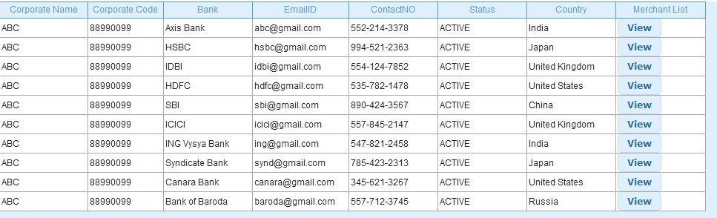

Validations for View Corporate List

None

